Doctor appointment system application (C#)

"Angel Kanchev" University of Ruse

Student: Marin Marian-Puiu

Year: 2

Class: Integrated Environments

Lecturer: Elitsa Ibryamova

*Contents*

1. Description of the task................................................................... 3
2. Database schema and details………………………………………. 4
3. User’s manual………………………………………………………… 6

**1)Description of Task 1**

*Design and implement a doctor appointment system as a Windows form application (Visual C#). The database must have at least three tables, for example (optional): doctors,patients,appointments. The software system should provide the user with the following options:*

* *Windows forms for visualizing the record from tables;*
* *Add, update and delete records;*
* *Searching by 1 or more attributes;*
* *Saving in Word or Excel files.*

*The documentation should consist of: Title page, text of the task description of the solution, database schema, and user’s manual*

**2)Database schema**

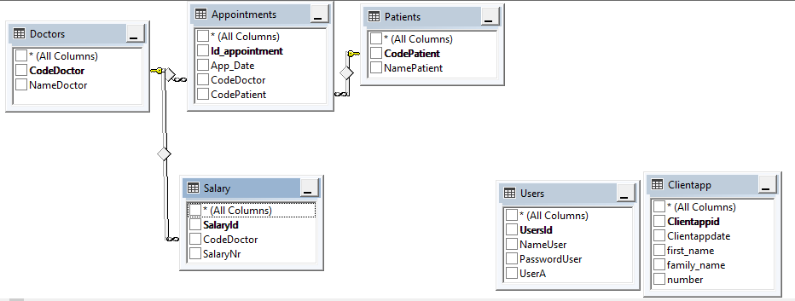

I create 6 tables, the main table is Doctors, it contains the code doctors and name. The code doctors column is used as a primary key here.

The second table is Patients, like first table, and the patients table contains the code patients and name, for this table is used as a primary key.

The third table is Salary, it contains code doctor as a foreign key, and the salary of the doctors and salary id.

The relationship between salaries and doctors is that one doctor has one salary.

The Fourth table is Appointments, it contains two foreign keys: code doctor and code patient, and the date of the appointments.

The fifth table is Users, it contains primary key(UsersId), I use this table for login and register system.

The sixth table is ClientApp, it contains primary key(Clientappid), I use this table for the new appointments.

Other queries that may be used in the program are:

1. Insert in table:

"INSERT INTO dbo.Appointments (CodeDoctor,CodePatient,App_Date) VALUES (@CodeDoctor,@CodePatient,@App_Date)"

1. "select NameDoctor from Doctors";
2. "Select NameDoctor,NamePatient,App_Date from appointments inner join doctors on appointments.codedoctor=doctors.codedoctor inner join patients on appointments.codepatient=patients.codepatient";
3. Select NameDoctor,SalaryNr from Doctors inner join Salary on doctors.CodeDoctor = salary.CodeDoctor where SalaryNr like " + bunifuTextBox1.Text;

**I use so much queries but I don't present here all queries.**

**3)User’s manual**

This is the main form for my application. I used bunifu for design.

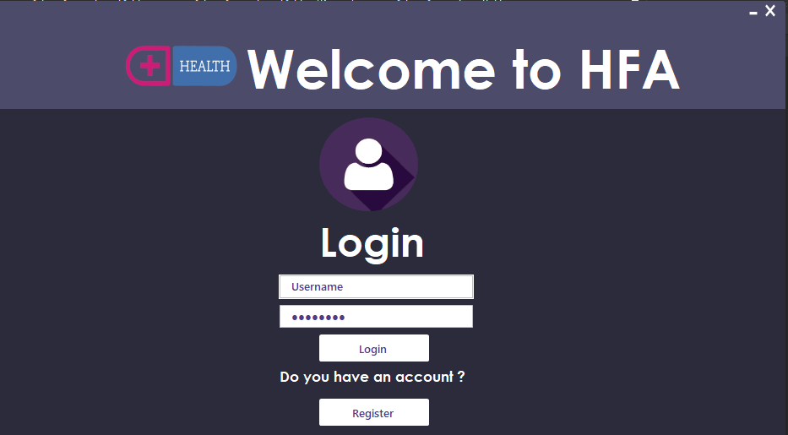Here you can login or register if you don’t have an account. I need has an account and I press register.

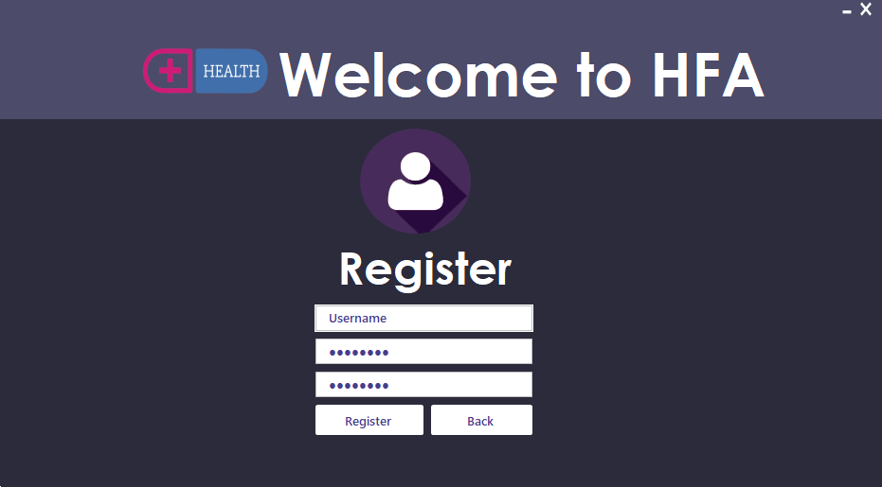

Ok, after you register with successful, you can login in the application.I created a system for admin and users if you register, you have a account for user.

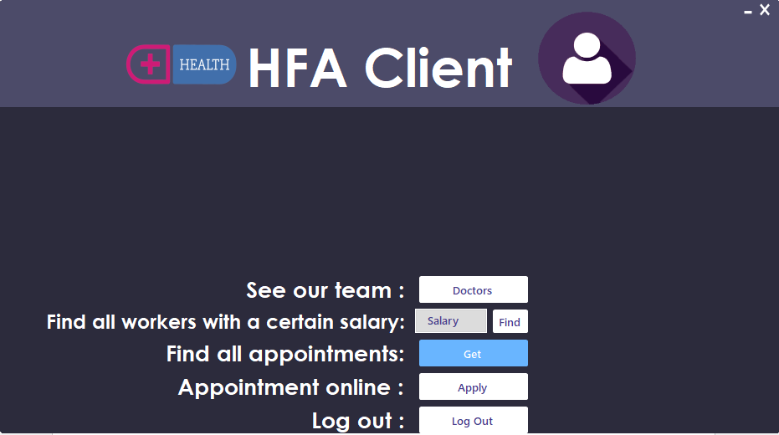

Here you have a menu with many options, for example if I press doctors,we will see all doctors.

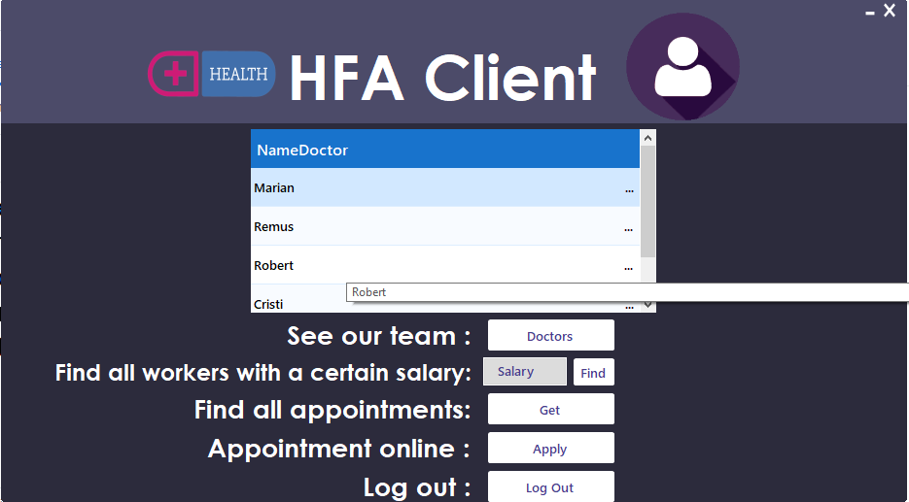

If you want an appointment, you can press on appointment online , here I used the same system as in register.

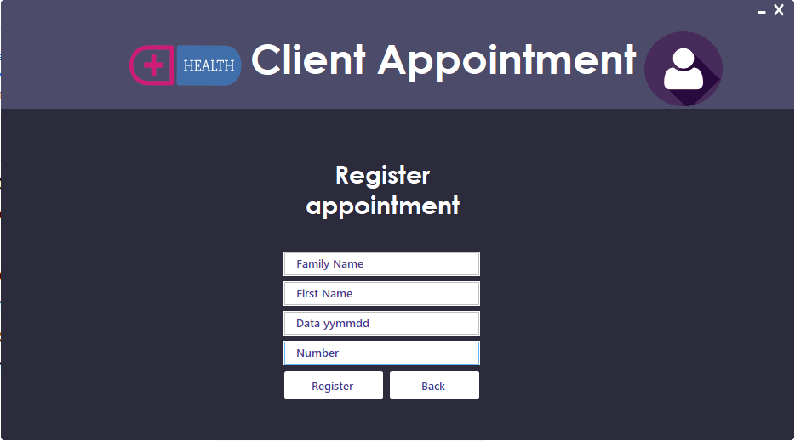

Ok, now I show you admins system.

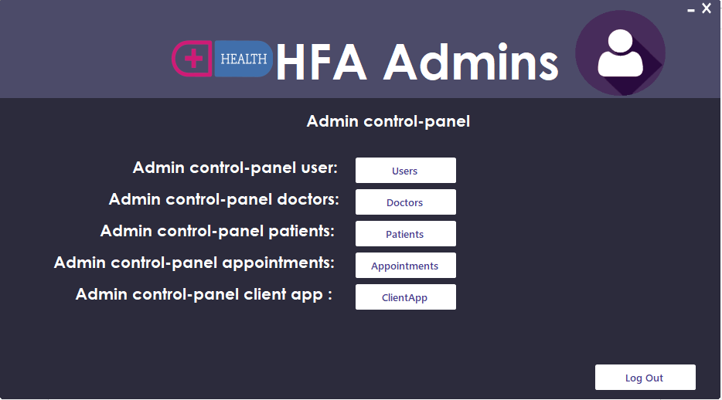

Like as in users menu you have many options.For example , I will press users button.

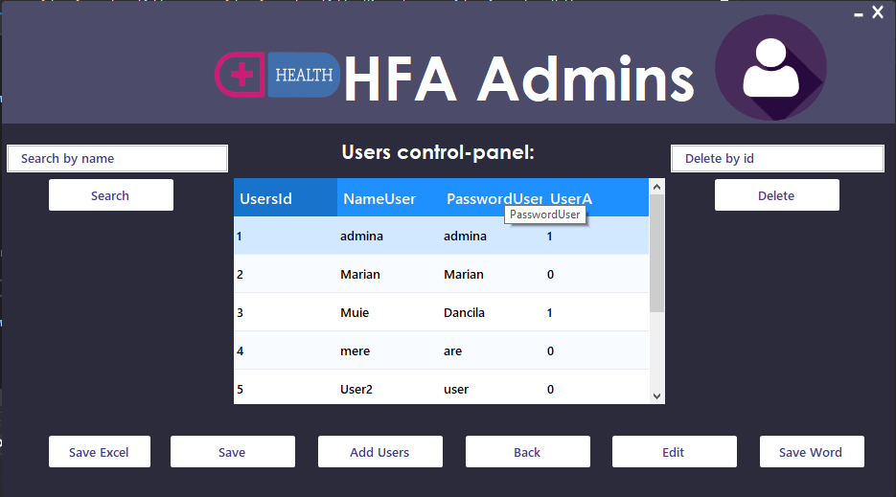

Ok, here we have many options.We can search a user by name, or delete user by id,save table in excel/word add a new user or edit a user.

Now I press add users button.

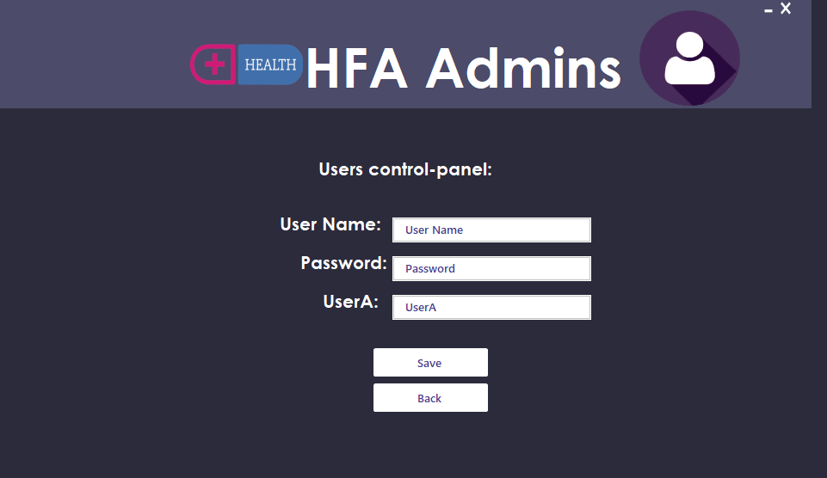

And here we have the same system like as in register, and button save insert into database.

At Edit user we have a new system.

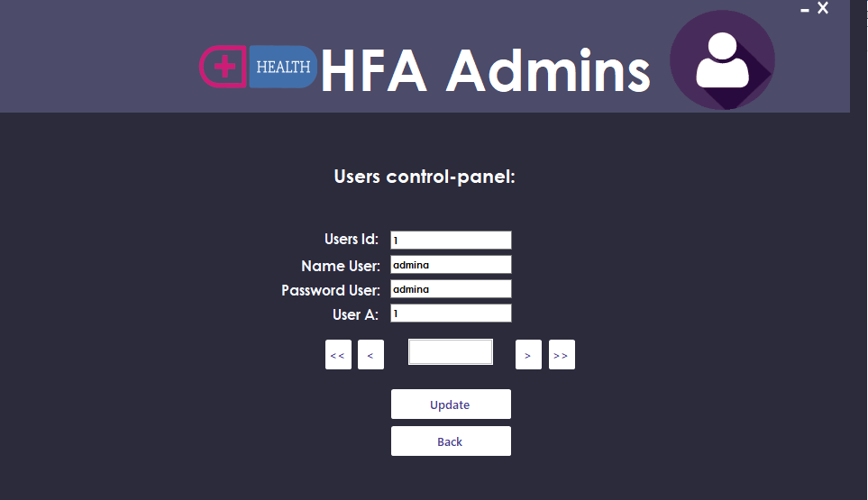

And we have buttons next,previous,first and last.



Now I insert a more explicit video.

[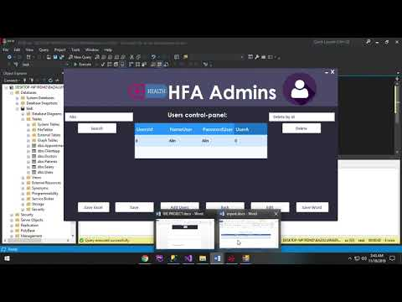](https://www.youtube.com/watch?v=msb11K1bGxk)